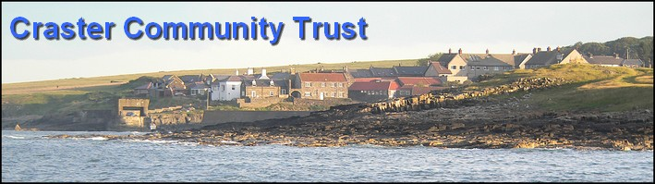

CRASTER COMMUNITY TRUST AGENDA
Meeting of Trustees
Thursday 25th November 2010 Memorial Hall 7pm

- Apologies  - Minutes of last meeting  - Matters arising  - Storage and Distribution of we can mind the time MG, JR  - Charity Shop Cabaret RR  - Lifeboat extension MG KB  - Treasurers report JR  - NWL monies GR  - Administrative matters GR Formal acceptance of trustee status  - Projects  - Memorial Hall  - Register of key holders MF  - Report from sub committee re progress with hall refurbishment. MF  - Play Park  - Report from subcommittee condition report and identification of progress into the refurbishment of the playground. HP, MG, KB  - Presentation of up to date weekly reports to committee for inspection. HP  - Other matters relating to the civil parish of Craster and its surrounding area  - Grant submissions MG  - Christmas Bingo HP  - Ceilidh RG  - Painting the Hall  - AOB  Meeting ends | 7.00  7.05  7.10  7.20  7.25  7.30  7.45  8.10  8.25

